# CONSUMER PURCHASE PATTERNS

# ASK

Using sales force data to analyze customer spending habits in order to increase sales performance. This information will be used to give recommendations on how to improve marketing strategy of products.

## BUSINESS TASK

The main objective is to put into place marketing strategies that will help improve marketing strategies in order to increase consumer products consumption and delivering of the right products to users.

## KEY STAKEHOLDERS

1. The director of marketing
2. Marketing analytics team.
3. Executive team.

## CHOOSE A DATASET

I’m using the SalesForCourse_quizz_table dataset from Kaggle.

## DELIVERABLES

Identify the customer spending habits. This will help businesses to know which products consumers mainly need.

# PREPARE

## Where is the data stored?

Data is stored in Kaggle as part of the Analyzing Customer Spending Habits data set. Data is stored in csv format showing customer habit per region.

## How is the data organized?

Good data obeys ROCCC (Reliable, Original, Comprehensive, Current and Cited) attribute.

The dataset is reliable. It contains data about timeline spending(date), revenue, unit cost, unit price and even the respective regions of customers.

The dataset is original. It was collected by original users.

The data was comprehensive enough for use.

The data is not cited but is available in Kaggle.

## ****How are you addressing licensing, privacy, security, and accessibility?****

The data was classified according to index

## How did you verify the data’s integrity?

The data has integrity since it is on Kaggle. Kaggle checks if its data has integrity before putting it in the platform

## **How does it help you answer your question**?

The data will help identify the trends in use by customers.

## ****Are there any problems with the data?****

The date columns are stored as strings. I will have to convert them to date.

# PROCESS

# What tools are you choosing and why?

I am going to use R.

## Have you ensured your data’s integrity?

Yes, I got the data from Kaggle.

## What steps have you taken to ensure that your data is clean?

I have removed rows that have null columns

I have ensured that the datetime columns are properly formatted

I have removed columns that have null values

## How can you verify that your data is clean and ready to analyze?

It has non-duplicate values. It has columns that have proper structure.

## Have you documented your cleaning process so you can review and share those results?

Yes, I have in the R script

# ANALYZE

## How should you organize your data to perform analysis on it?

I have renamed column index to id. I have also added other columns like margin and unit margin

## Has your data been properly formatted?

The date was converted to the appropriate consistent format

## What surprises did you discover in the data?

The profit margin for bikes in United States was very poor

## What trends or relationships did you find in the data?

High revenue on a product in a country does not estimate to high margins. Increase in margins increase at the age of 20 and decrease at the age of late 4os.Revenue increased on July 2015 and decrease on July 2016.

## How will these insights help answer your business questions?

It will enable me to know which group of consumers are using which product and at which time of the year

# SHARE

According to average profit per month diagram, the profits are better in the middle of the year compared to the beginning and the end . Apart for the month of June.

According to the margin per age graph most profits come from people who are in between the age of late 20s and early late 40s.

With analysis from the below chart , United states has the highest Revenue.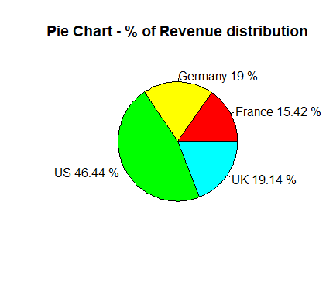

The analysis for the Margin distribution per country is considered below.

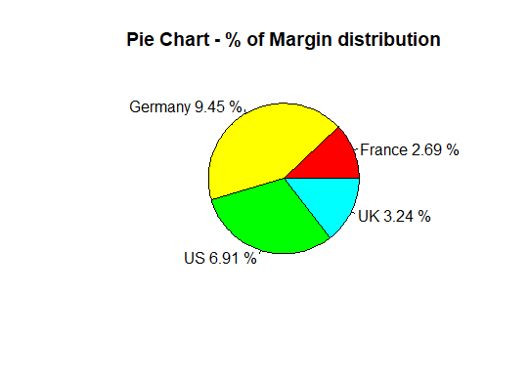

In accordance with the margin per country image, United States is making negative profit margin in bikes.

With the Quantity per country image, all products are uniformly distributed between all the countries and states

United States consumes most of the revenue and yet makes very poor profits.

# ACT

The recommendations are:

1. Put better marketing and promotions for bikes in all the countries especially united states. People need to know the fun for using bikes especially in United States.
2. Standardize the price for bikes in United States just like Germany.
3. Can offer promotions of buying bikes and giving out accessories or clothes as prizes especially in United States. This can be mainly done in the last three months (festive) in order to boost sales.
4. Can put points as a marketing strategy for those buying accessories. Especially for people in their 20s and 30s.These points can be redeemed to buy clothes. This will improve margins for clothes.
5. Since most people in their 20s and 30s are buying clothes and accessories, a marketing campaign can be put in place to encourage them to buy bikes which are more profitable. For example bike offers and free healthy exercises on bikes.

## ACKNOWLEDGEMENTS

I acknowledge Mr. Vineet Bahl for his data set which contributes heavily to my analysis on data set.

Link reference: https://www.kaggle.com/datasets/thedevastator/analyzing-customer-spending-habits-to-improve-sa